I. Introduction
In this Business Case Proposal, I will select URCovered Inc. as a business case to show a technological solution for a business problem. The following paper provides background of URCovered, its problem statement, and audience of this systems proposal.
1. Background
URCovered Inc. is one of the largest major auto insurance companies in North America. It’s management plan to invest a mobile application which can improve the satisfaction of customer. URCovered’s current claims management system was implemented about five years ago. With the development of smartphone, more and more consumers prefer to choose digital transactions. The ease and convenience of mobile devices shifted the medium by which consumers access information, conduct transactions, and manage their personal lives. Some surveys indicate that almost claims which are the leading call driver in URCovered can be resolved by mobile claims management system, without the necessary to talk to the agents. That means, an improved mobile claims management system, which can offers another approach for self-service for customers, will not only drastically decrease inbound call volume but also save time for customers.
2. Problem Statement
Even though the management believe that mobile claims management system is a great idea, there are still several problems. For instance, the mobile application may affect negatively for the customer relationship. In general, the contact with the case manager and customer is more personal. After using the mobile application, customers may feel disconnected and then lose the personal connection. Besides, case manager also concerns the information accurate. If a customer find that his claim is still in a pending status, he might think his claim is not approved. However, the internal status is complexed and positive to the case manager who can properly communicate the interpretation of the pending status. What’s more, security identical is also an important problem. The username and password that use in the mobile application usually can access URCovered website. Thus, it’s necessary to take measures to protect customers’ private information.
3. Audience
If the mobile claims management application is adopted, there are several groups whose feedback will be critical. Firstly, customers. Customers are the best candidates to examine whether this mobile claims application meet the demands or not. URCovered can invite some customers to provide their feedback into how they imagine such an apple would function. Secondly, claims managers. Because this application play a role of supplement for claims manager, it’s necessary to know their expectations, concerns, and recommendations. Finally, web developers. Many functions are available both in mobile application and web page. To protect customers’ private information and other else reasons, it’s important to work with web developers.
IV. Project Plan
URCovered Inc. has decided to invest a mobile application to improve the satisfaction of its customers. This part of the paper will explain how to make work breakdown structure (WBS), project monitoring and control plan, and timeline.
Work Breakdown Structure
A work breakdown structure (WBS) refers breaking a project down into a series of smaller tasks. As Project Management Body of Knowledge (PMBOK) defines, WBS is a deliverable oriented hierarchical decomposition of the work to be executed by the project team. (www.workbreakdownstructure.com) First of all, there are essential roles and functions required for this plan as follows:
- Project manager. A project manager need to not only coordinate the whole team’s work
but also allocate the resources used in the project.
- System analyst. System analyst will get involved in the project when a change occur or
new additional requirement from customers.
- QA analyst (informally called tester). QA analyst makes sure the product meet the
Standards and good product is delivered.
There are two primary types of charts in WBS: Gantt charts and PERT/CPM. A Gantt chart, which appears as a horizontal bar chart, present an overview of the project’s status. PERT/CPM is used to large, complex project. It’s a bottom-up technique. (Rosenblatt, H. J., 2010) In this paper, Selecting Gantt chart is more fit than another. The Gantt chart is show as follows:
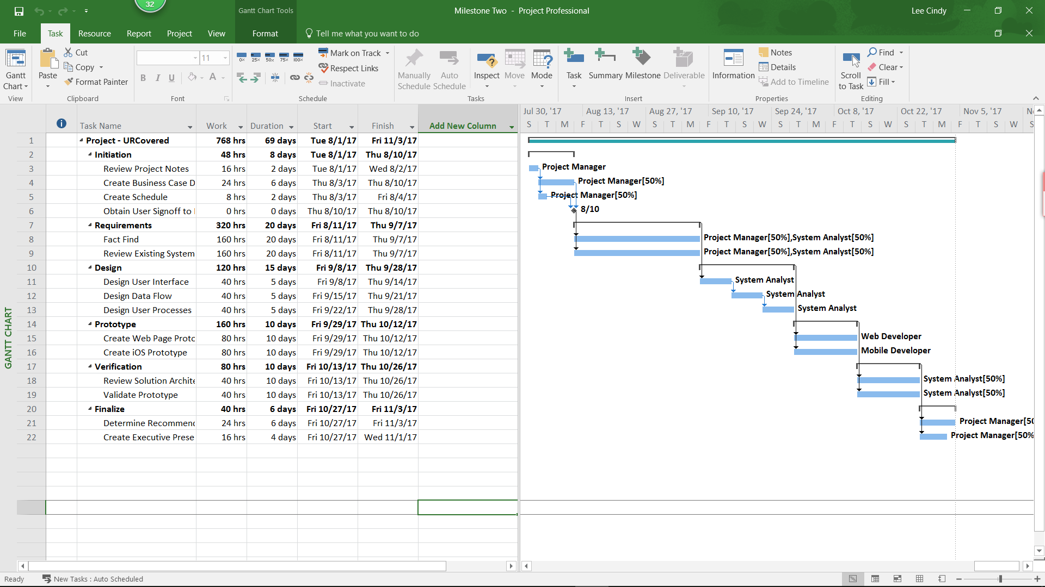
Project Monitoring and Control Plan
One of the key steps in a project is maintain the schedule because problems always occur during the project. By monitoring and controlling the work, project manager attempt to predict problems, and then avoid or minimize their impact. (Rosenblatt, H. J., 2010)
    - Key Performance Indicator: This indicator helps in collecting the performance information based on status reports, progress reports and forecasts. This will help decide any corrective actions that are needed to be implemented in the middle of the development cycle.
    - Schedule Control: Schedule control plan will let the managers know of any schedule changes like the deadline changes etc. The major areas where the schedule control can effect are the performance measurements, activity list and activity and attribute processes.
    - Cost Control: This plan will include the cost estimation and baselines updates. The project cost can be affected due the changes in the scope of the project. Hence, the cost control plan is needed to balance the project cost with the new/changing requirements emerging very frequently.
    - Quality Control: The outputs of quality control plan include the quality control measurements, validate defect and the solution to repair, recommended alternate solutions to the possible defects. authenticated deliverables including the updates to the company wide process resources.
Timeline
In this paper, the project’s timeline is showed as follows:
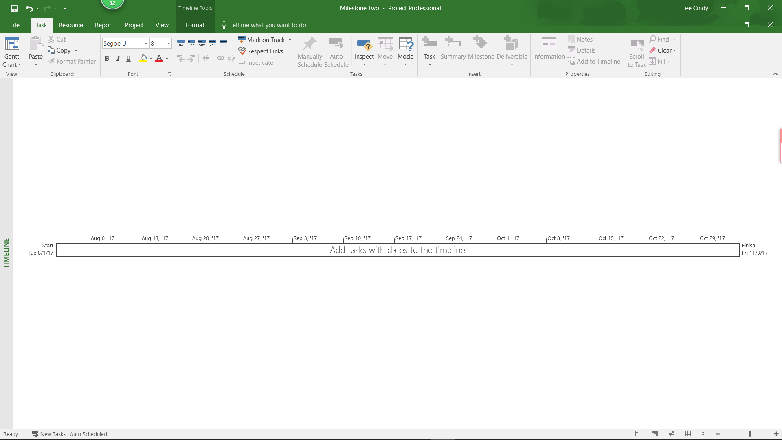
Besides, the resource sheet below has the cost estimations to each and every type of re-source involved in developing the mobile application to the URCovered.
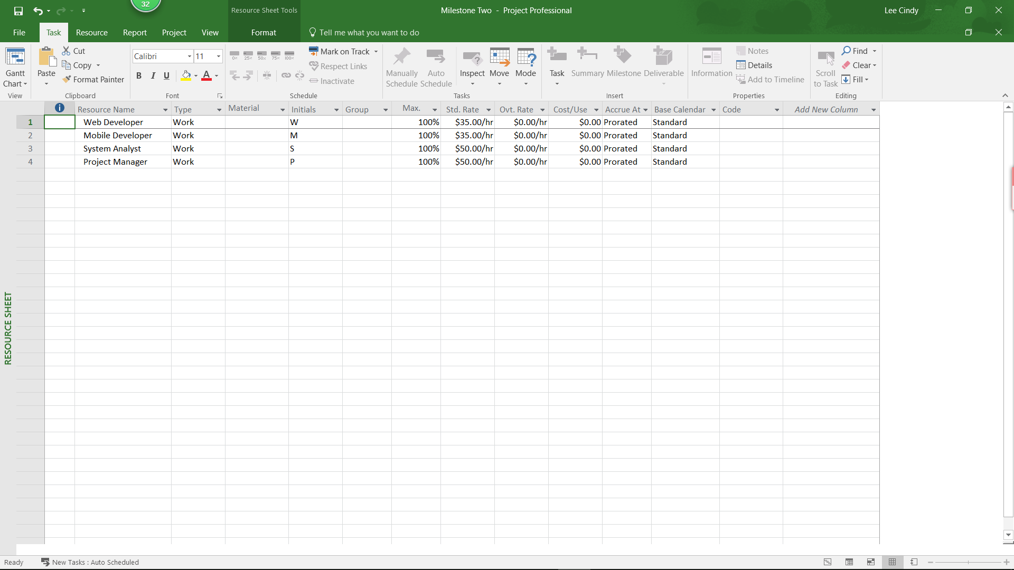
Finally, below Screen shot provides the information about the total cost based on the total number of hours the employees are working.
